**Implement program to apply moving average smoothing for data preparation and time series forecasting run in python code**

**EX.No:7**

**DATE:**

**AIM:**

To apply Moving Average Smoothing for trend analysis and forecasting using Python.

**ALGORITHM:**

1. Import pandas and matplotlib libraries.
2. Load the time series dataset and convert the date column to datetime format.
3. Set the date column as index and resample the data.
4. Apply Moving Average using rolling().mean() function.
5. Plot original data and smoothed data for comparison.

**CODE:**

import pandas as pd

import matplotlib.pyplot as plt

df = pd.read_csv('Plant_1_Generation_Data.csv')

df['DATE_TIME'] = pd.to_datetime(df['DATE_TIME'], errors='coerce')

df.set_index('DATE_TIME', inplace=True)

df['AC_POWER'] = df['AC_POWER'].ffill()

print("Dataset Information:\n", df.info())

print("\nMissing Values:\n", df.isnull().sum())

print("\nDescriptive Statistics:\n", df.describe())

window_sizes = [3, 7, 14, 30]

for w in window_sizes:

df[f'MA_AC_POWER_{w}'] = df['AC_POWER'].rolling(window=w, min_periods=1).mean()

print("\nFirst 10 Rows After Smoothing:\n", df.head(10))

plt.figure(figsize=(14, 7))

plt.plot(df.index[:1000], df['AC_POWER'][:1000], label='Original AC_POWER', color='blue')

for w in window_sizes[:2]: # Plotting 3 and 7 window MA

plt.plot(df.index[:1000], df[f'MA_AC_POWER_{w}'][:1000], label=f'MA_{w}', linestyle='--')

plt.xlabel('Date')

plt.ylabel('AC Power')

plt.title('Moving Average Smoothing')

plt.legend()

plt.show()

**OUTPUT:**

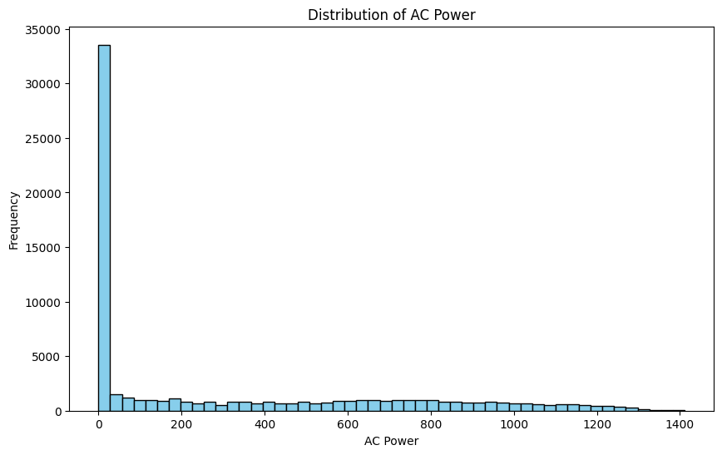

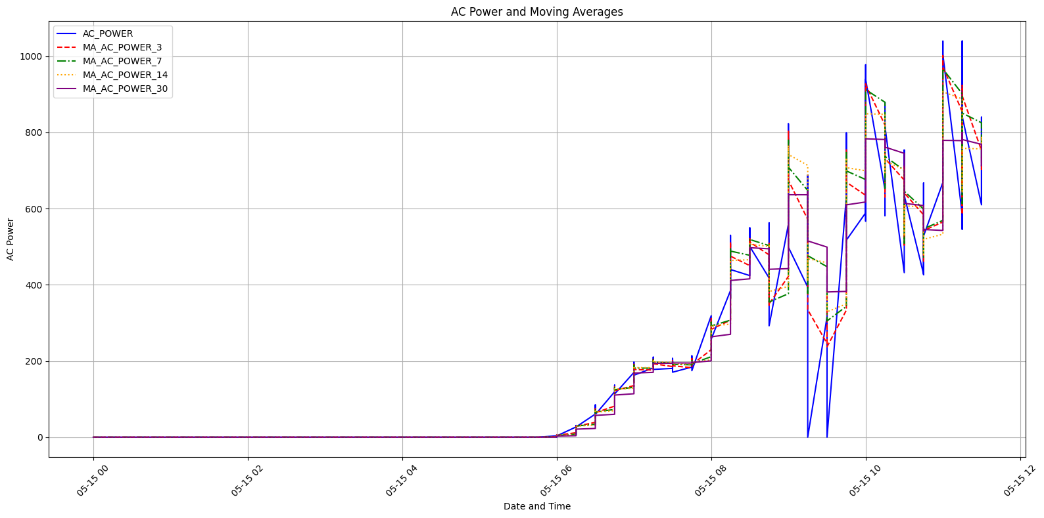

**RESULT:**

Thus the program has been completed and verified successfully.